# Home page:

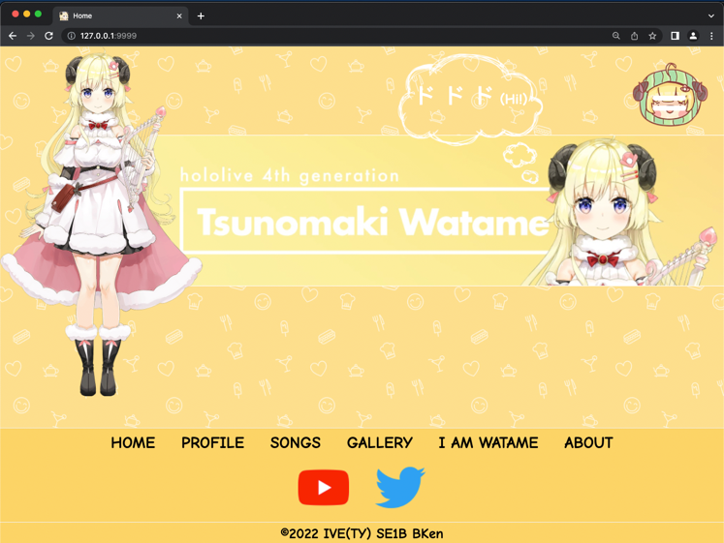

The image and the banner have animation (line-in) when the document is loaded.

The text has animation (fade-in) when the document is loaded.

# Main Menu:

Users can click the top-right menu button to open this menu. The menu will drop down from the top. The background image will adjust according to the screen size.

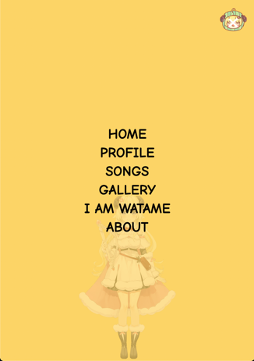 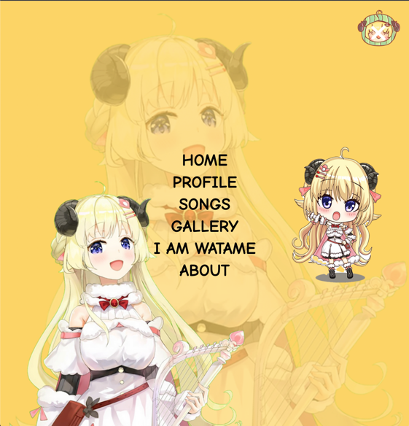

# Footer:

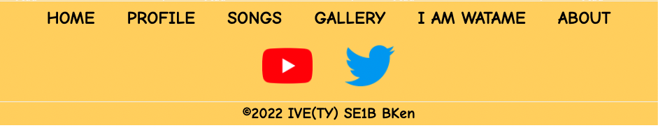

# Profile pages:

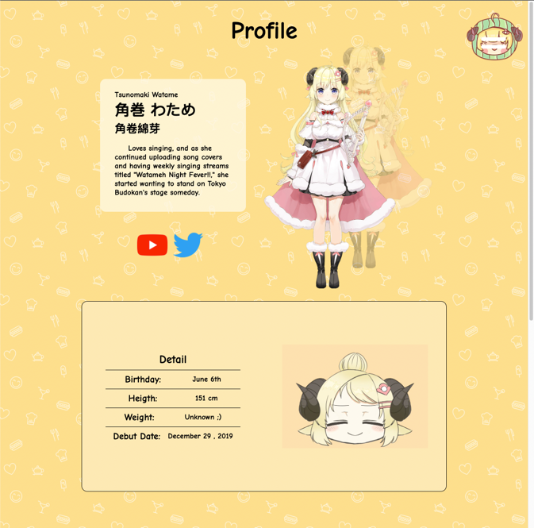

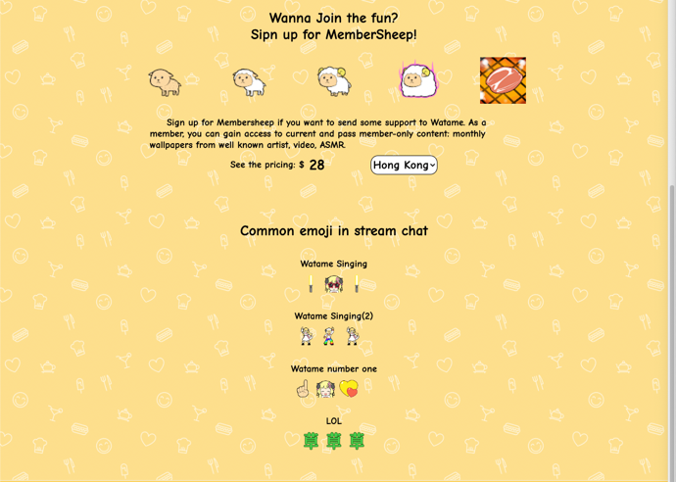

The web pages will ask users sure to go to an external link (the social media of Watame) before forwarding the user.

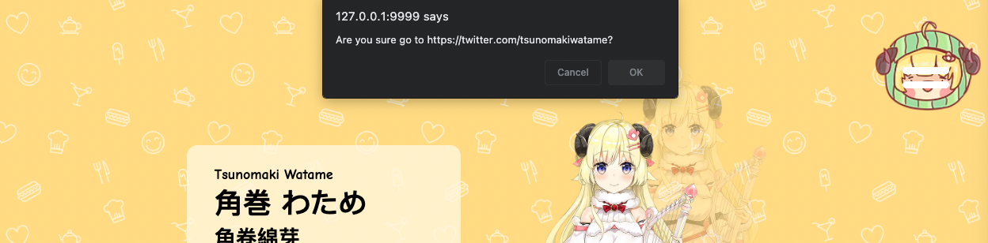

The price of a Watame member will change according to the choice of the country that the user selected.



# Songs pages:

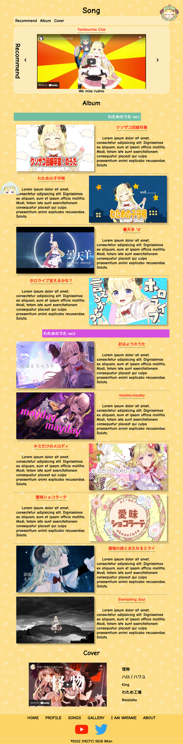 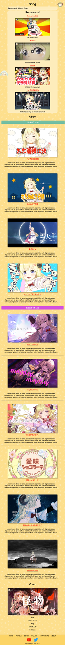

CSS menu:



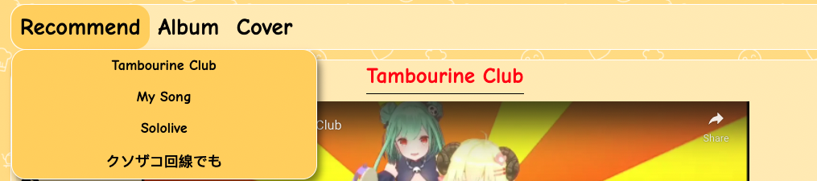

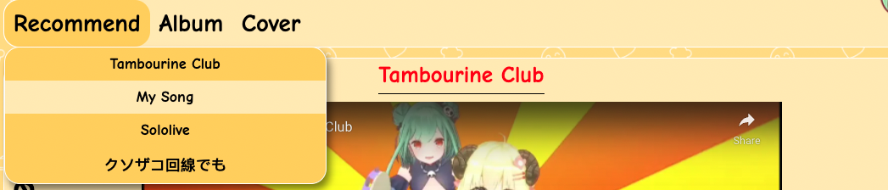

The user needs to click on the "Menu" to show the CSS menu when the screen size reaches certain width.

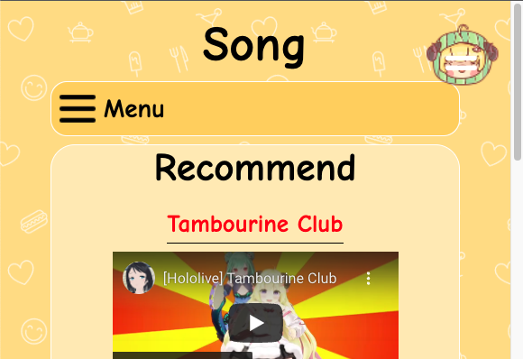 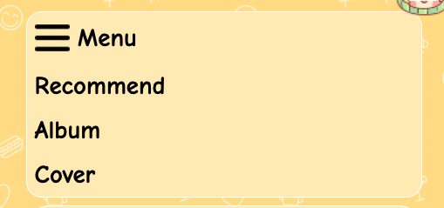

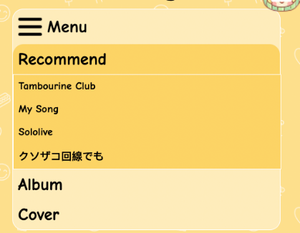

Top button: the user can click the button to back to the top of the page

Origin: 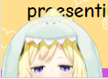 change:

The songs pages are divided into three sections.

Recommend section:

The user can press "<" or ">" to change the video.

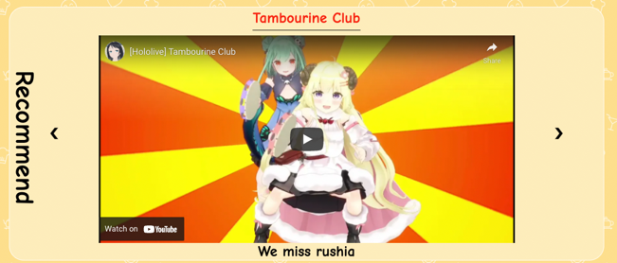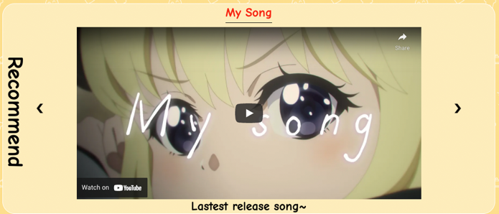

Album section:

One song has a cover and its description. Users can click on the photo to watch the video. The user can click anywhere or the "X" to close the pop-up window. The video will automictically stop.

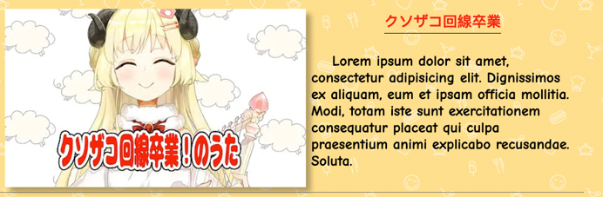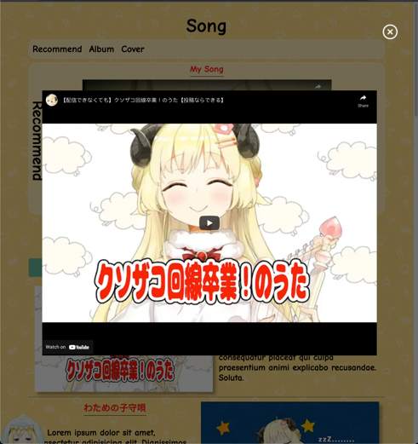

Cover section:

The user can click the song’s name on the right side to see the video.

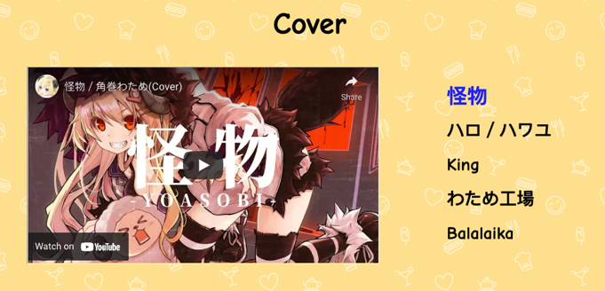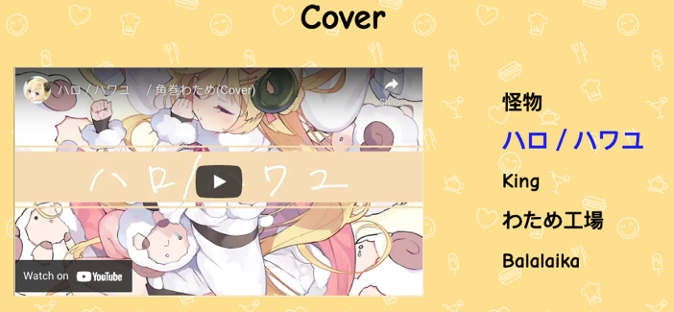

Gallery Pages:

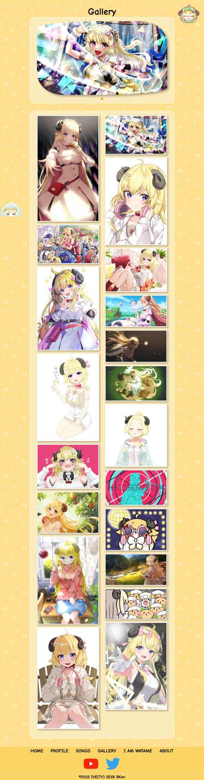 

Carousel :

The photo will changes itself time by time. The user can click on the photo to see it more clearly. The user can click anywhere or the "X" to close the pop-up window.

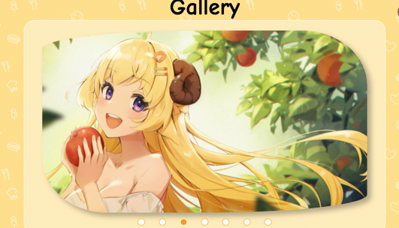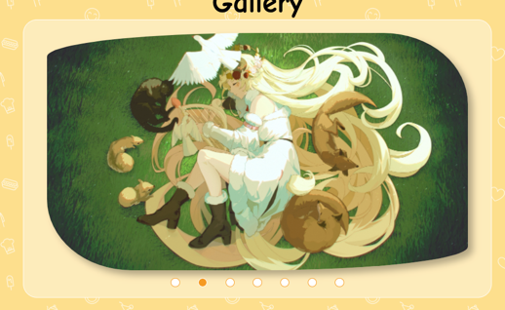 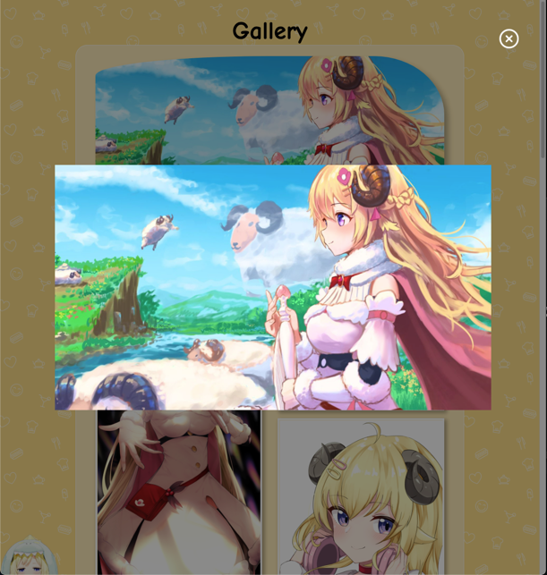

Waterfall:

Different size images are placed together as a gallery. The user can click on the photo to see it more clearly as above.

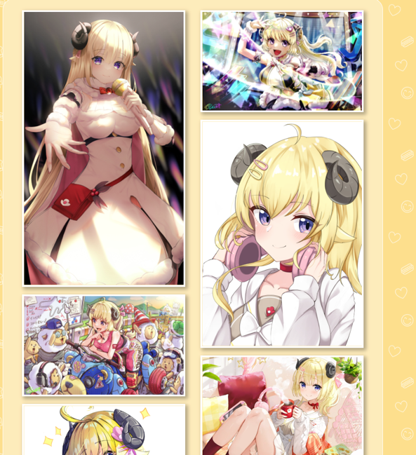

I am watame pages:

Audio of the watame sound will be played when the user clicks the button. When the user clicks the "Back" button, the photo and text will change back to default.

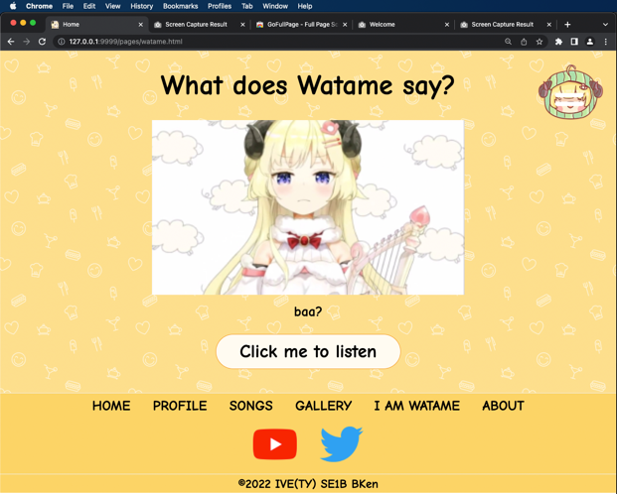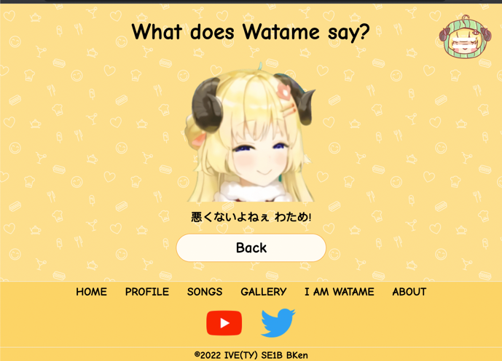

About us pages:

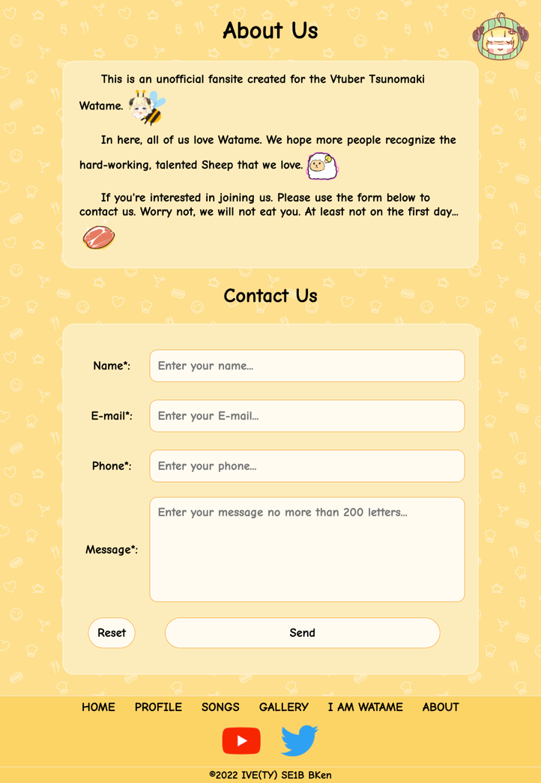

The form is divided into two parts to check the input.

The name uses html5 attribute to check the pattern.

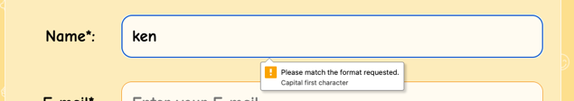 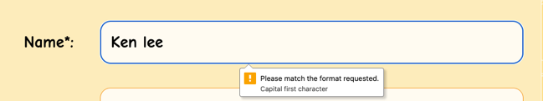

The remaining three-part use Javascript to check the pattern. And display a label and a red border when the input does not match the pattern. The border will automatically change back to normal when the user clicks on the input boxes. The user can manually close the menu by clicking on "x".

